STROKE TEAM TO COMPLETE
THROMBECTOMY PATHWAY

mmm
Time & date of referral for intervention* / : : / /
Onset time* : : Unknown* □ Wake up Stroke* □

Time thrombolysed : Not throbolysed □

Referred from (name of Hospital)* ______________________________________
Name & mobile number of referring doctor _____________________________________
Name of patient ______________________________________
Address of patient _______________________________________
Date of birth _______________________________________

Time of referral to interv neuroradiologist :

Time of referral to anaesthetist :

Time ambulance departed referring hospital* : : Helicopter used* Yes □ No □

Time of arrival to ED at RSUH : He

Time of Stroke Team assessment :

Time of first brain imaging at RSUH* :

Start consent form □ done
Empty bladder/put on convene/pad if time □ done
Hospital gown if time □ done
If not for thombectomy state why:*
□ Not required/no large artery occlusion
□ No salvageable penumbra

Time of arrival at IR suite :

SEAT nurse: ______________ Stroke consultant _________
STROKE TEAM and/or ANAESTHETIST TO COMPLETE
Specialty of anaesthetist (if present)*: Neuroanaesthetics □ General anaesthetics □
Stoke Thrombectomy Health Assessment Form:-(please complete for ALL mechanical thrombectomy patients)
NIHSS on arrival |  |  | NIHSS now |  |  |  |  |  | mRS Score |  |  |  |  | Thrombolysis
Bamford | TACS |  | PACS |  | LACS |  |  | POCS
CT-Angio | Left |  | Right |  | ICA |  |  | M1 |  |  | M2 |  |  | Basilar |  | Other |  |  |  | Dissection
Past Medical/Surgical History (please tick all that apply)
General | Weight_____ (kg)  Height _____ (cm) |  | Last Food | Time__________
 |  |  | Last Drink | Time__________
 | Allergies: |  | Previous Anaesthetic Complications
Lifestyle | Smoker |  | Renal | AKI
 | Alcohol |  |  | CKD
 | mRS |  | Metabolic | T1DM/ T2DM
Respiratory | COPD/ Asthma |  |  | Hyperlipidaemia
 | OSA |  |  | Thyroid Dysfunction
 | Other |  | Haematology | Anaemia
Cardiovascular | Hypertension |  |  | Coagulopathy
 | Angina/ MI |  |  | DVT/PE
 | Heart Failure |  | Central Nervous | Previous Stroke
 | Atrial Fibrillation |  |  | Previous TIA
 | PPM/ICD/CRTD |  |  | Epilepsy
 | Other arrhythmia |  | Malignancy | Site:
 | Other heart problem |  | Previous Surgery | Site:
Medication History | Drugs given
Drug | Dose | Drug | Dose |  | Drug | Dose | Time
Clinical Assessment
General:

Chest:

Heart:

Legs:

Skin and Joints:

Investigations
Hb |  | Na |  | Gluc
WCC |  | K
PLt |  | U
INR |  | Cr
Observations
Time: - RR Sats HR BP Temp BM

RADIOGRAPHER TO COMPLETE
Lead Operator:______________ (□ Interv. neuroradiologist □ Interv. radiologist □ Trainee)*
Operator 2: _______________ (□ Interv. neuroradiologist □ Interv. radiologist □ Trainee)*
Nurse: ____________________ Radiographer: ________________
Pre-OP checks | □ Informed Consent  □ WHO complete
What intervention lab was used?* | □ Biplane □ Monoplane  If Monoplane used why?*  □ Biplane in use □ Biplane being serviced □ Other
Puncture site | □ Femoral □ Radial  □ Left □ Right
Anaesthesia* | □ General Anaesthetic □ Local Anaesthetic only  □ Conscious Sedation □ LA/ Sed converted to GA
On Table CT time:
Pressure bags:
- 1% Lidocaine □ 2 Litre Hartmanns
- Nimotop 0.02% 3mg/15mls □ Visipaque 320
- 1Litre Hartmanns □ Heparin Sodium BP 500IU/500ml
- Heparin Sodium 1,000IU/ml
Anaesthetist: _____________ ODA: ________________________
□ Right side | □ CCA □ ICA □ VA
□ Left side | □ CCA □ ICA □ VA
Sheath: □ Long □ Short

Guiding catheter:

Intermediate catheter:

Time consent signed by INR : :

Time patient on table :

Time INR scrubbed :

Time of groin puncture* :

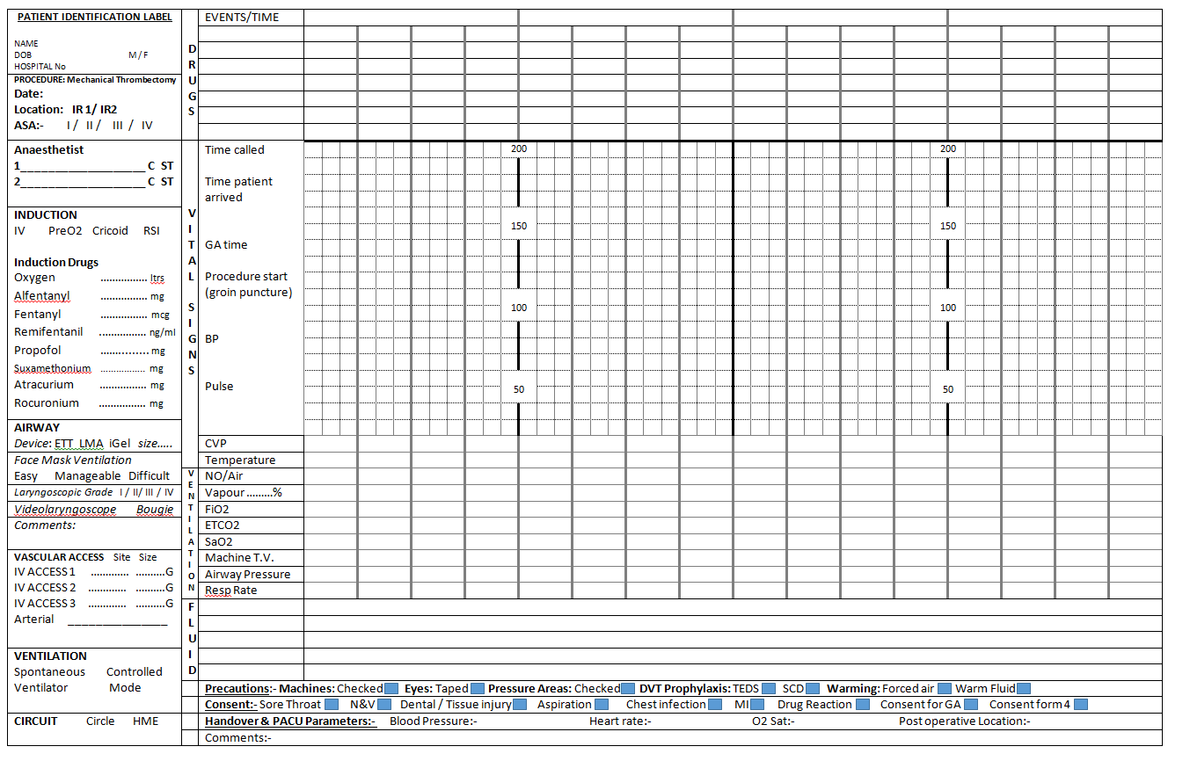

(Thrombectomy procedure sheet- Lead operator Interventional Neuroradiologist)

Time of arterial puncture* :

First deployment of device for thrombectomy or aspiration* :

End of procedure (last angiographic run on treated vessel)* :

How many device passes were required?*
Cervical Carotid stenting* Yes No
Cervical Carotid angioplasty Yes No
Other stent or angioplasty Yes No (specify if yes) _______________
Thrombectomy not performed* □Not applicable
□ Unable to obtain arterial acces □ Procedure begun but unable to access the target vessel
□ Medical condition caused the procedure to be abandoned □ Other reason ____________

Which method(s) were used to reopen the culprit occlusion?*
a. Thrombo-aspiration system Yes No
b. Stent retriever Yes No
c. Proximal balloon/flow arrest guide catheter Yes No
d. Distal access catheter Yes No

Were there any procedural complications? (select all that apply)*
a. Distal clot migration/embolisation within the affected territory Yes No
b. Embolisation to a new territory Yes No
c. Intracerebral haemorrhage Yes No
d. Subarachnoid/intraventricular haemorrhage Yes No
e. Arterial dissection Yes No
Arterial dissection Yes No
If yes which vessel is dissected/perforated:
f. Vasospasm Yes No
g. Other Yes No
Angiographic appearance of culprit vessel and result assessed by operator (modified TICI score – circle appropriate score)*
a. Pre intervention 0 1 2a 2b 2c 3
b. Post intervention 0 1 2a 2b 2c 3

Devices used:
MT Device 1 (specify) : Vessel: No of passes:
MT Device 2: (specify): Vessel: No of passes:
MT Device 3: (specify): Vessel: No of passes:
MT Device 3: (specify): Vessel: No of passes:

Free text operator’s note

1. | Closure Device (specify) | 6fr 8 fr none
2. | Bed rest until
3. | Angioseal post procedure care | 2 hours flat
 |  | 2 hours sitting
3. | Neuro Observations
4. | NBM until
5. | Groin check/ Radial check every hour till
6. | BP Parameters | Between - mmHg
7. | Contact Doctor if patient deteriorates
8. | Post procedure medication

Where was the patient transferred after the completion of the procedure?*
Stroke unit RSUH □ Stroke unit at referring site □ ITU or HDU □ Other □

If transferred to ICU or HDU, what was the indication for high-level care?*
Unstable BP □ Airway or cardiac instability □ Bleeding at procedure site □ Failure to wake from anaesthetic □Agitation/need for sedation □ Renal failure □ Other □ None of the above □

