- TRIAL SUMMARY

Trial Title | A randomised controlled trial of the effectiveness of intermittent surface neuromuscular stimulation using the geko™ device compared with intermittent pneumatic compression to prevent venous thromboembolism in immobile acute stroke patients
Internal ref. no. (or short title) | GEKO Venous Thromboembolism Prevention Study
Trial Design | Prospective, multicentre, randomised controlled trial
Trial Participants | Age 18 years or older  Clinical diagnosis of acute stroke (WHO criteria)  Within 36 hours of symptom onset  Not able to get up from a chair/out of bed and walk to the toilet without the help of another person
Planned Sample Size | At least 1200
Treatment duration | 30 days or until the patient is independently mobile or discharged into the community, whichever is the earliest
Follow up duration | 3 months
Planned Trial Period | 01Dec 2022-30 Nov 2025
Inclusion/Exclusion Criteria | Inclusion Criteria:  - Age 18 years or older  - Clinical diagnosis of acute stroke (WHO criteria)  - Within 36 hours of symptom onset  - Not able to get up from a chair/out of bed and walk to the toilet without the help of another person | Exclusion Criteria:  - Inability to gain consent from the patient, or a declaration from a Personal Consultee or Nominated Consultee  - Unwitnessed onset with a long lie on the floor before admission  - Clinically apparent deep vein thrombosis at screening  - Patient is expected to require palliative care within 14 days  - Patient does not live in the local catchment area and is expected to be transferred to their local hospital for on-going care.  - Patient has recently been involved in or is currently involved in a clinical trial for either a medical device or medicinal product, within the past 3 months, with the exception: if co-enrolment is not considered to impact adverse events or outcomes in the opinion of the Chief Investigator. (A live document containing a list of approved studies will be included in a reference document made available to all study sites and available upon request)  - Contraindications for the use of the geko™ device:  - Allergy to hydrogel constituents.  - Contraindications to IPC:  - Severe peripheral vascular disease  - Large leg ulcers requiring extensive bandaging (small ulcers or skin breaks with flat coverings are not an exclusion)  - Severe oedema.  - Leg deformities making appropriate fitting impossible  - Uncontrolled congestive cardiac failure  - Pregnancy  - Single or double leg amputations
Objectives |  | Outcome Measures
Primary | To determine whether the geko™ device is more effective at preventing venous thromboembolism within 30 days of randomisation than intermittent pneumatic compression in immobile patients with acute stroke. | Any symptomatic or asymptomatic deep vein thrombosis (DVT) in the calf, popliteal or femoral veins or any confirmed fatal or non-fatal pulmonary embolism (PE) within 30 days of randomisation
1.Secondary outcomes up to 30 days | To compare effectiveness and tolerability | - Patient tolerance of the device at day 14  - Adherence to allocated treatment to day 30  - Death from any cause by day 30  - Confirmed fatal or non-fatal PE to day 30  - Any symptomatic or asymptomatic above knee DVT to day 30  - Any symptomatic or asymptomatic DVT in popliteal or femoral veins and symptomatic calf vein DVT to day 30  - Combined c-e
2. Secondary outcomes at 90 days | To compare survival, functional outcomes, and quality of life | - Leg pain (NRS scale)  - Death from any cause  - Any symptomatic or asymptomatic DVT or PE occurring between randomisation and final follow-up  - Combined b and c  - Disability (modified Rankin Scale)  - Health related quality of life (EQ-5D-5L)  - Place of residence.
Exploratory and health economic outcomes | To compare exploratory and health economic outcomes | - Early neurological recovery (difference in NIHSS between baseline and 7 days)  - Neurological recovery (difference in NIHSS between baseline and 14 days)  - Stroke recurrence up to 30 d  - Length of hospital stay at 90 days  - Home time at 90 d
Safety outcomes up to 30 days | To assess safety | - Falls with significant injuries  - Fractures  - Skin breaks  - Adverse events (additional to those listed above)
Investigational Device | The geko™ neuromuscular electrostimulation device (Firstkind Ltd, High Wycombe, UK)
Control | Intermittent pneumatic compression (IPC) using any NHS approved device
Application of the device/control | geko™ therapy / IPC will be applied to both legs as soon as possible after randomisation and continued 24 hours a day until independent mobilisation/discharge into community or for a maximum of 30 days.
Funding | National Institute for Health Research i4i Research Grant

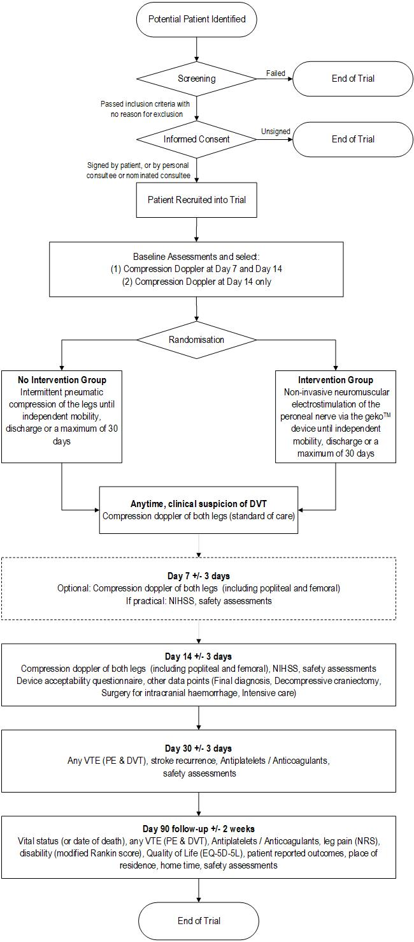
- TRIAL FLOW CHART

